Objective
To gain experience on creating derived classes and inheritance.
Project Description
Take the code we've provided for the Employee class (Employee.h) and the Manager class (Manager.h).

Add methods to the classes named:
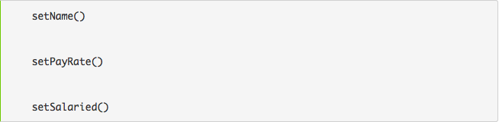
that let users change the corresponding fields. Take advantage of the inheritance relationship between Employee and Manager--you only need to add each of those methods to 1 class.

Write a Supervisor class. A supervisor is responsible for employees in a specific department and must:
- Have a field to store the department name (as a string).
- Have getDept() and setDept() methods to access the department field.
- Always be salaried (i.e., pay for a single pay period is fixed, no matter how many hours are worked).
- Have a constructor that takes initial values for all fields.
- What class should Supervisor inherit from?
Your code should compile and run correctly with the test program: Empltest.cpp.

Upload your modified files (upload - do NOT zip them! - your source files: Employee.h, Manager.h, and new file Supervisor.h) for the assignment below.

Grading Policy
(30 points) Grading of this programming assignments will reflect two factors, weighted as shown.
Correctness -- Does the program run correctly. (25 points)
Style -- Does the code follow the Documentation and Submission Guidelines? Is the code well structured, readable? Do you paste your output as the comment after the main function? (5 points )

